Genetic Genealogy Overview

Genetic Genealogy is a new and evolving field that provides genealogists with tools that support family tree building. To understand the benefits of Genetic Genealogy it is useful to have a broad understanding of the biology of DNA and the genealogical usefulness and limitations associated with each DNA type. What we refer to as our DNA (a seemingly singular term) actually has four distinct components, three of which are widely used in genetic genealogy. Our DNA resides in virtually all cells within our bodies. It contains the genetic instructions used in growth, development, functioning and reproduction. DNA provides the mechanism for passing inherited traits on to succeeding generations.

There are two structures within each of our cells that contain our DNA.
- The most familiar place that we find our DNA is in the nucleus of each of our cells. The nucleonic DNA consists of 23 pairs of chromosomes. The majority of our DNA (~99.999%) is contained within in these 23 pairs. One of each of pair is inherited from our mother and one from our father.
  - We need to further segment the 23 chromosomal pairs into two distinct groups. One pair of the 23 are referred to as the “sex” chromosomal pair and the remaining 22 pair is referred to as autosomal pairs.
    - For the sex chromosomal pair, the biological mother passes an X chromosome to the embryo. The father passes either an X chromosome or a Y chromosome to the embryo. If an X is passed by the father the offspring will be female, and if a Y is passed the offspring will be male.
    - For the 22 autosomal pairs, one of each pair is inherited from the biological mother and one from the biological father.

- The less familiar place we find our DNA is within each mitochondrial structures that exist in the cell’s cytoplasm. Cytoplasm is the cellular material found within the cell’s wall but external to the nucleus. Mitochondrial DNA consists of about 0.001% of our DNA.

Of the 4 distinct categories of DNA mentioned this far (X Chromosome (X-DNA), Y Chromosome (Y-DNA), Autosomal Chromosomal pairs (atDNA)and Mitochondrial (mtDNA), X-DNA is not generally useful for genealogical purposes and will not be further explored in this narrative. Each of the remaining 3 DNA categories will be explored for their genealogical relevance.

Significant DNA Genealogical Factors
Again, the three types of DNA testing widely used in genetic genealogy are: Y-DNA, Autosomal DNA (atDNA), and Mitochondrial DNA (mtDNA). The genealogical significance of Y chromosome testing is that the Y chromosome is passed from father to son “essentially” unchanged. Another way of thinking of this is to “Cut” the Y chromosome from the father, and to “Paste” a copy of the father’s Y chromosome into the genome of the son. This is not a perfect analogy as there may be mutations in this copy process resulting in a nearly perfect, but on occasion a slightly different copy is passed on to the son. Mutations occur infrequently, yet in predictable intervals. Accordingly, these mutations, or lack thereof may be used to infer generationally, when two modern day tested males may have had a common ancestor; a key ingredient in understanding how two males may be related on a family tree. One additional point of significance, once a mutation does occur, the mutated Y chromosome continues to be passed down the paternal line.

Next consider the Mitochondrial DNA. mtDNA has the inheritance characteristic of being passed from a mother to her children. The father’s mtDNA is not passed to offspring. This characteristic of only being passed from mother to child provides a genetic path to explore one’s maternal line. You carry, regardless of being male or female a copy of your mother’s mother’s mother’s …….. mtDNA. A down side to mtDNA testing is that mtDNA comprises only a very small portion of your total DNA ( ~.001%) and accordingly the genealogical usefulness in identifying how matched individuals are related is limited, but can come in handy from time to time.

The third category is autosomal (atDNA). This DNA type comprises 93% of one’s DNA. As previously mentioned, one of each of the 22 autosomal pair of chromosomes comes from the genetic father and one from the genetic mother. At this point it is easy to see that 50% of autosomal DNA is inherited from each parent (one chromosome from each). For Autosomal DNA matches and projected relationships are based on the amount of shared DNA two tested persons have. As a rule of thumb, offspring inherit 50% from each of 2 parents. Grandchildren inherit 25% of their genetic material from 4 grandparents (courtesy of parents) and so on. This shared DNA predictive model has high confidence at 3rd cousins and closer relationships, but can be used at lower confidence levels for more distant relationships. Remember that autosomal testing does not render a determination of an individual being male or female as the sex chromosome is not contained in the autosomal chromosome set. The following chart provides each relationship and the percentage of common atDNA expected for each relationship.

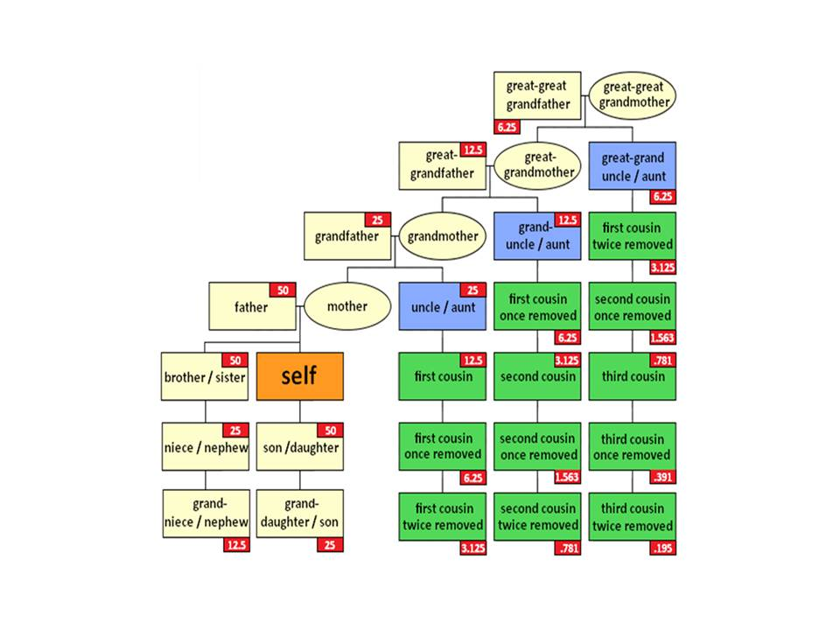
Which Genealogical DNA Test Is Right for You
The technology is interesting, recent, and evolving. For maximum benefit for one’s genealogical interests, decisions are often required. What test or tests will support your genealogical goals? What specific tests should be focused upon? Refer to the notational family tree provided below. If you are interested in a paternal line; i.e. a particular surname line, then obviously Y-DNA is the right test choice. Y-DNA testing can only be performed by males of the line of interest (since only males carry the Y-DNA). Female researchers interested in pursuing a paternal line should elicit the support of a male who is known to be of the line of interest. Y-DNA testing provides the genealogist insight into how two tested Y-DNA matching individuals may be related. Tools are provided to point to the past generation where two males had a common ancestor. In addition matches are provided with contact information (email) of tested individuals who are matches. Collaboration between or among matching individuals is encouraged to deepen the understanding of how two matching persons may be related.

There are several Y-DNA test options available. As a starting point, Y-DNA 37 is the minimum test level recommended (this tests 37 locations along the Y chromosome). Y-DNA 67 provides better resolution in assessing how individuals who either exactly match, or closely match may be related. Y-DNA 111 may be helpful to more precisely determine when two “matches” shared a most recent common ancestor. As mentioned, Y-DNA 37 is the minimum level of testing recommended. It should be noted that Y-DNA 37 test can be upgraded to Y-DNA 67 and Y-DNA 67 may be upgraded at a later date to Y-DNA 111 for an incremental cost. Additionally, an upgrade to Y-DNA 500/700 is also available for an incremental cost.

Y-DNA as well as mtDNA testing can help researchers understand elements of their genealogy extending far beyond the “historical time frame”. Such ability allows tested individuals to understand anthropological ancestry and the associated migration paths of ancient ancestors. As mentioned the proportion of one’s mtDNA is very small. Accordingly the full mtDNA sequence is recommended for best research benefit.

atDNA cannot extend far back in time to encompass pre-historical time periods as is the case with Y-DNA and mtDNA, but does provide an ethnicity profile extending through the genealogical time frame (~ 500 years or about 20 generations). atDNA provides the ability to reliably predict relatedness of matching individuals up to 3rd cousins. Relationship predictions beyond the 3rd cousin level are possible, but with reduced confidence. While Y-DNA provides insight into ones paternal line, and mtDNA provides insight into one’s maternal line, atDNA provides the ability to estimate matching person’s relationship in any of one’s recent family tree branches.

